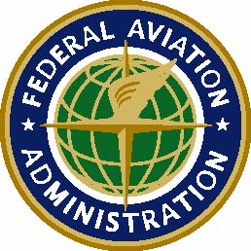 | Federal Aviation  Administration  Guam Air Route Traffic Control Center  1775 Admiral Sherman Blvd  Barrigada, GU 96913
Memorandum
Date:

To:

From:

Subject:

